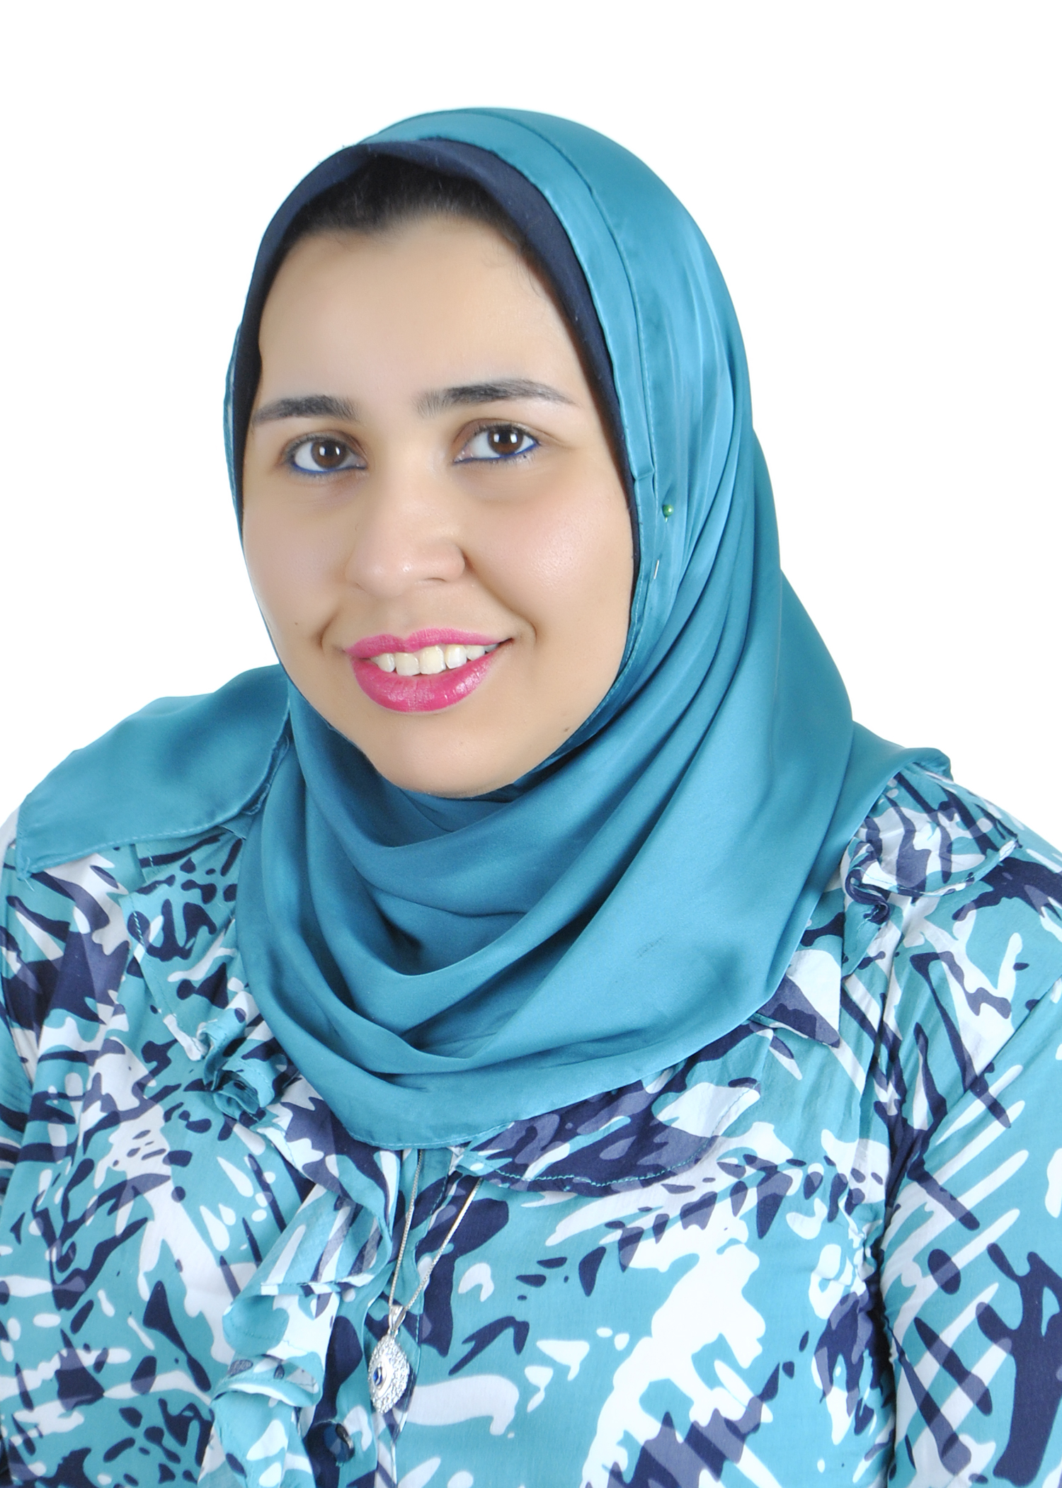
nashwa moustafa nagy

Villa no. 10, 103 St., Maadi
Cairo, Egypt
Telephone: (202)25251549
Mobile: (20)1023034002
E-mail:moustafanashwa@yahoo.com

objective:
Seeking a challenging position where my theoretical and practical experience could be developed and enhanced in a prestigious organization.

education:
- 2010-present Helwan University Helwan, Egypt
Faculty of Applied Arts, textile engineering Dept , PHD

- 2006-2010 Helwan University Helwan , Egypt
Faculty of Applied Arts, textile engineering Dept , MSC
Grade: good

- 2001-2006 Helwan University Helwan , Egypt
Faculty of Applied Arts, textile engineering Dept , BSC
Grade: good.
PATENTS:
- 2010 Registered patent of the MSC in the name "Medical Gauze Treated with Microencapsulating Technique for Wounds Treatment", National Institute OF Research, Cairo, Egypt.
skills:
Computer Skills:
- Excellent Knowledge of MS Office
- Excellent Knowledge of Photoshop & Coral Draw
- Excellent knowledge of textile designing & embroidery programs
- Good knowledge of network and communication
- ICDL
- Graphic Diploma
- 3-D Max Diploma

Language Skills:
- Native language Arabic
- Excellent command of both written and spoken English{Local & International Toefl}
- Good command of both written and spoken Dutch{Flemish}

Other Skills:
- International engineering arbitration course-Fidic.
- Several courses from National Authority for Quality Assurance and Accreditation of Education.

Experience:
- Sep 2012-present Benha University, Faculty of Applied Arts, Spinning, weaving and knitting department.
(assistant lecturer)
- Jan2013-Feb2014 Egyptian engineering syndicate – Authority of arab engineering arbitration
(executive secretary)
- March 2012- Dec 2012 Hindawi Publishing Corporation
(graphic specialist)
- Sep.2011- Feb 2012 Amal American School
(coordinator of the American division)
- June 2010-Oct 2010 Basic Business Skills Acquisition (BBSA) Cairo, Egypt
Sponsored by the Future Generation Foundation (FGF)
Training
- Developed Language and Computer skills
- Enhanced Presentation & project development skills
- Acquired basic business skills including: marketing, sales, banking, accounting, business correspondence and report writing.
- GRP graduate, Resource program:
- Dale Carnegie "Sales Advantage"
- Dale Carnegie "Negotiation Skills"
- Dale Carnegie Seminar "Communication Skills"
- Dale Carnegie "World Class 1 Customer Service"
- Berlitz "Proposal Writting"
- Jan 2009-May 2010 Nosha Linen Factory {self project}
(Head Manager and master designer)
- July 2008-Nov 2008 Mobinil
Training
- Customer Service Interface Induction
- Call Center
- Development team member
- Dec 2007-March 2008 International Elastic Industry (Free Zone) Cairo, Egypt
Training
- Master planner for the development division
- Doing visibility study and market analyst
- Customer Service Support
- Aug 2007-Dec 2007 Delta Textile Egypt (Free Zone) Cairo, Egypt
Training
- Team member of the American development division
- Customer Service Assistant
- February 2006 Gab Tex training period For 4 months
- May 2005 Hessni Factory training period For 1 months
Wart shire Factory Mar burg, Germany
(Observation, Limited Participation)(21 days)
- May 2004 Gab Tex training period For 1 month
- Jun 2004 El-shorbagy training period For 1 month
- May 2003 EL-shorbagy training period For 1 month

interests:
- Firm and confident leadership skills.
- Strong research methodology and management skills.
- Extensive experience in academic funding and scholarship.
- Strong networking ability with the international community.
- Reading, traveling, solving problems, working in a team and creating new friends.
Personal Information:
Date of Birth: 16/4/1985
Marital Status: Single.

